**Name :** V Venkata Sri Prasad

**Batch:** Data Engineering

**Date:** 25/04/2023 – Day 7

Topics:

1. Python introductions
2. Control statements
3. List, Tuple, Set ,Map and their methods

Writing and Running First program:

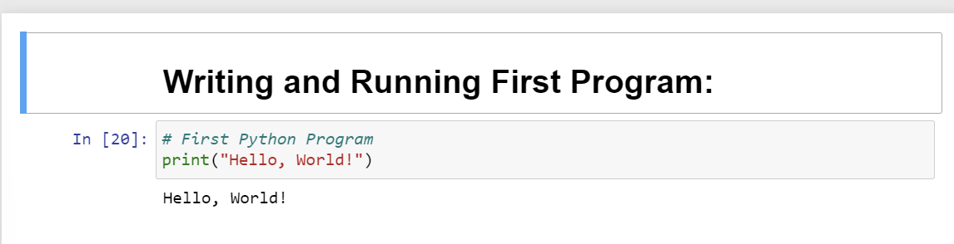

Keywords & Identifiers

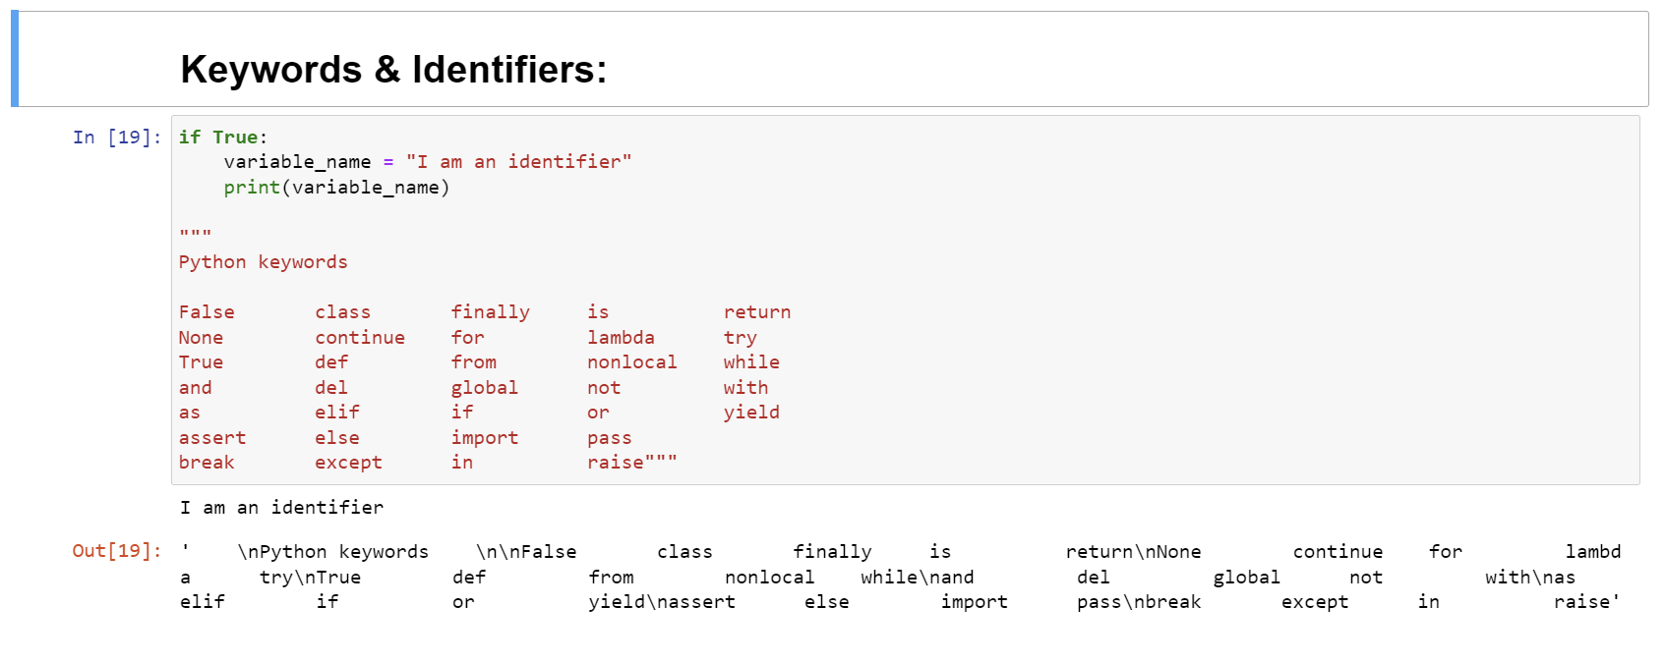

Variables & Operators

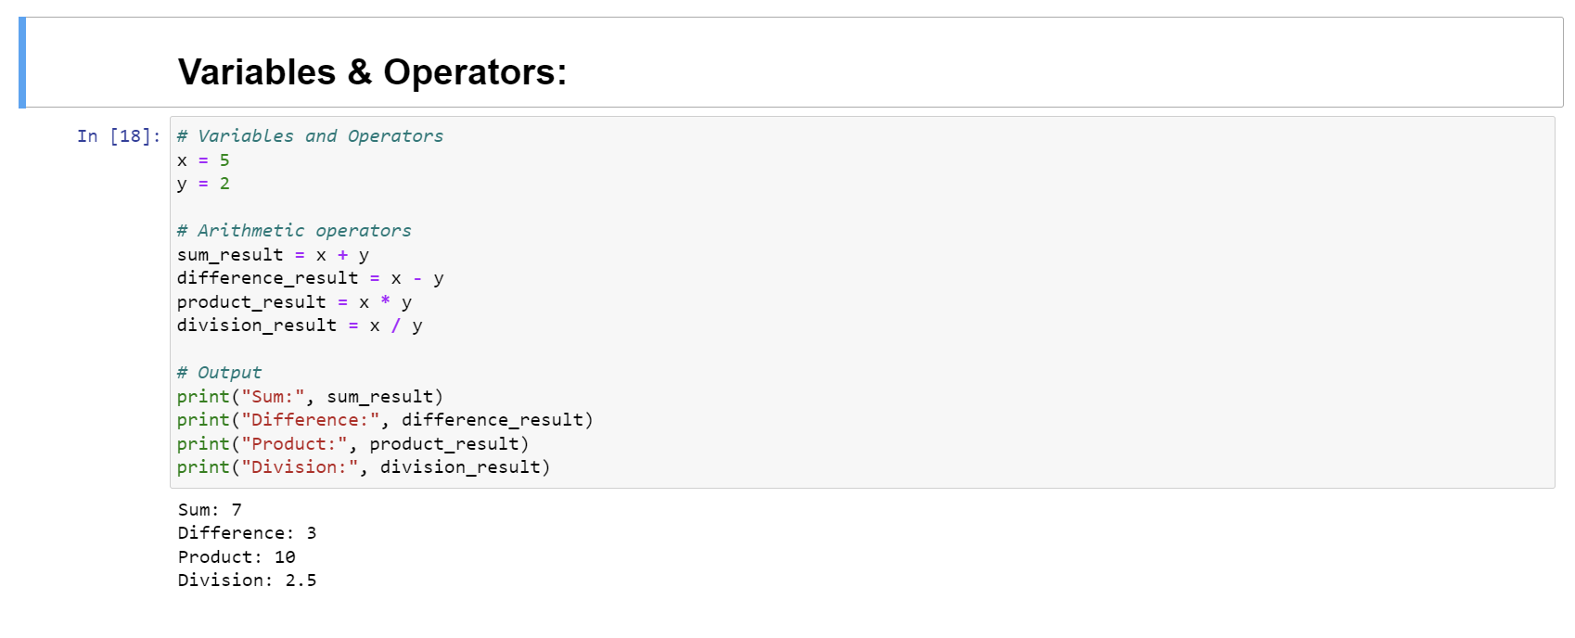

Data Types

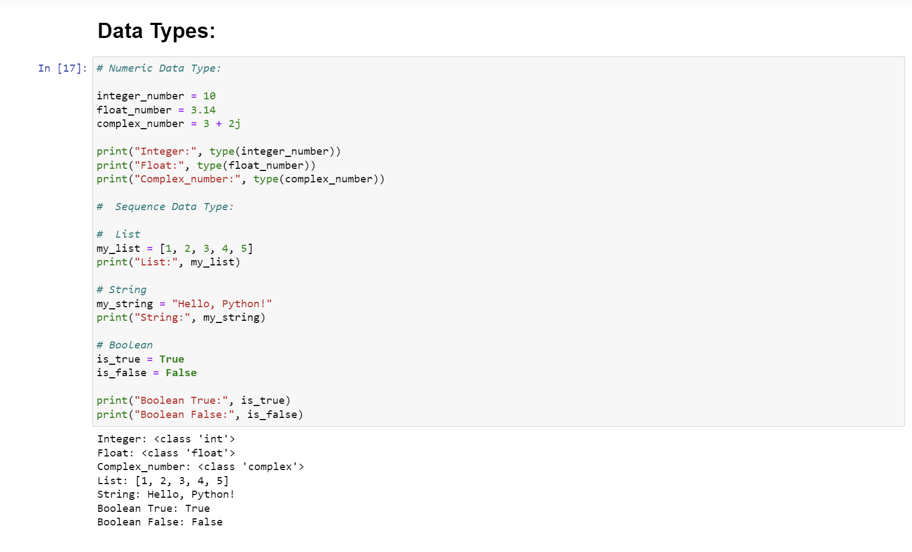

If statement:

If-else statement:

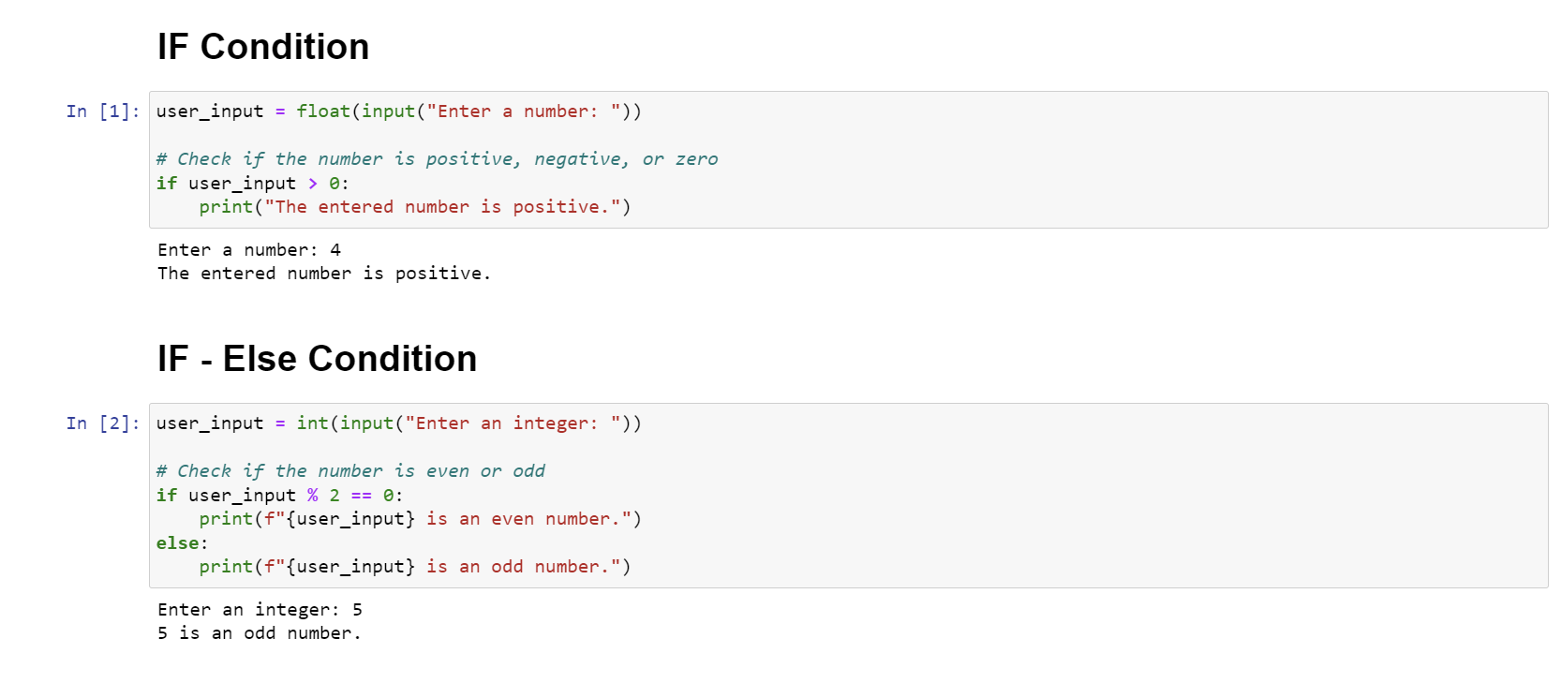

If-elif-else statement

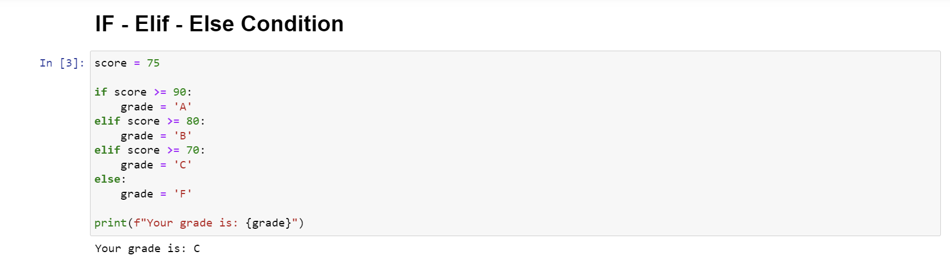

Control Structure

For Loop:

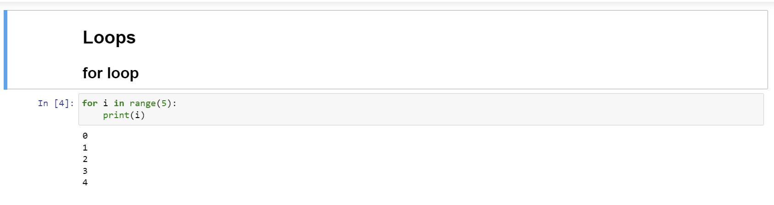

While Loop

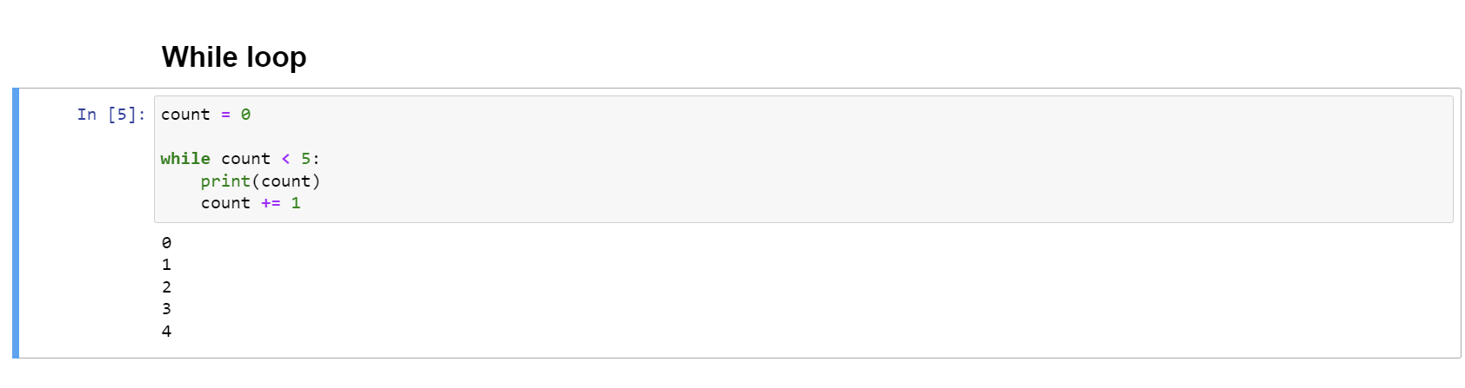

Nested Loop

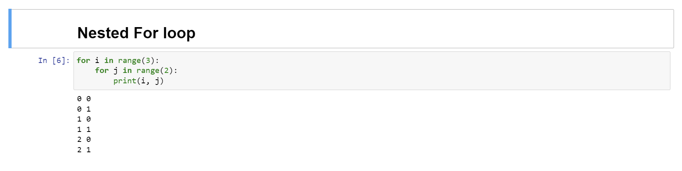

Break, Continue & Pass

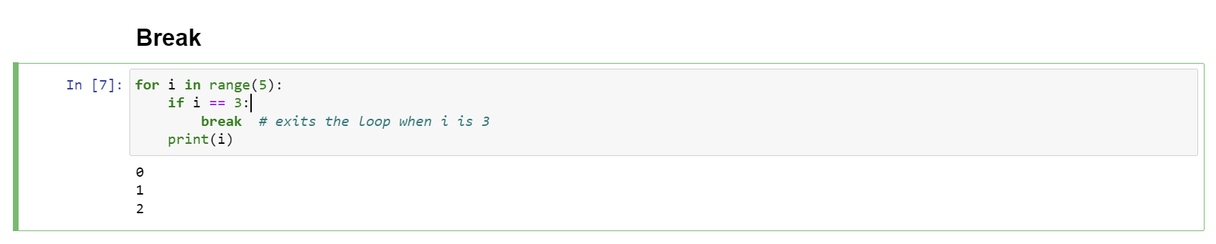

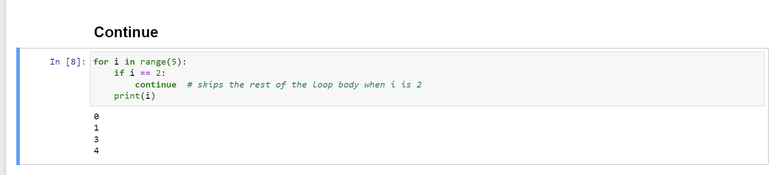

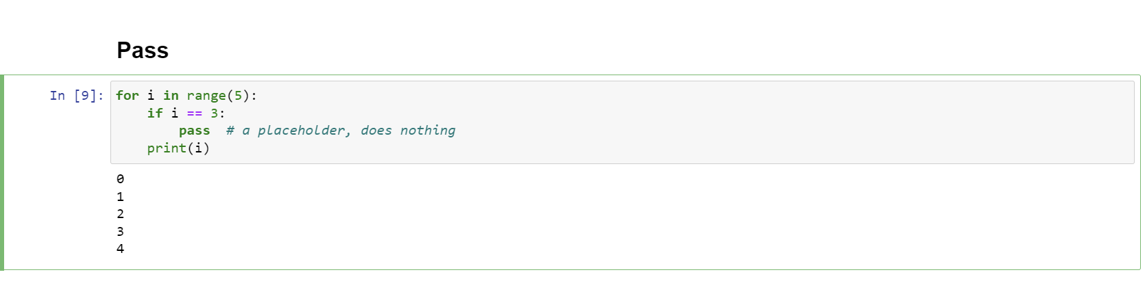

Introduction to Lists

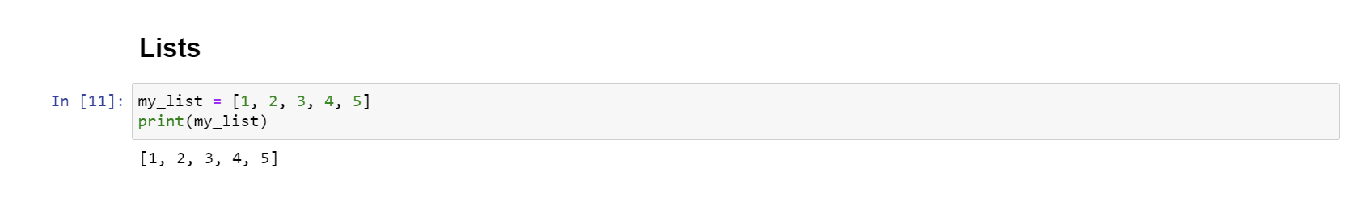

List Methods and Slicing

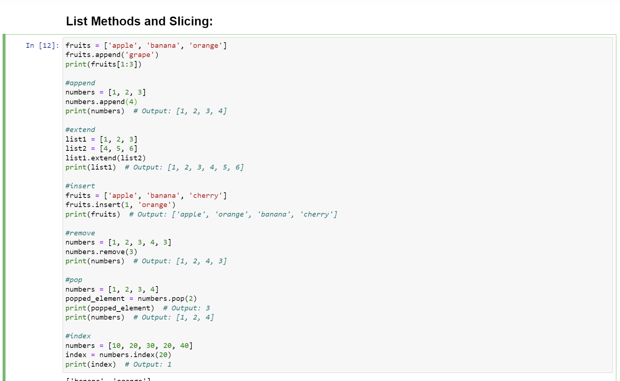

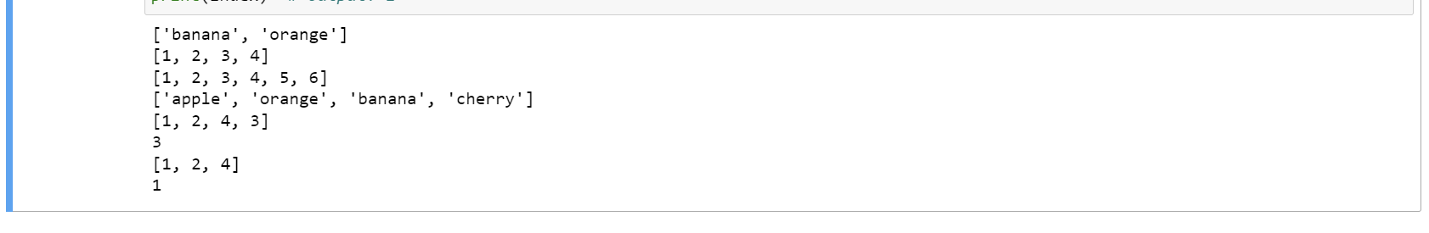

Introduction to Dictionaries & Dictionary Methods

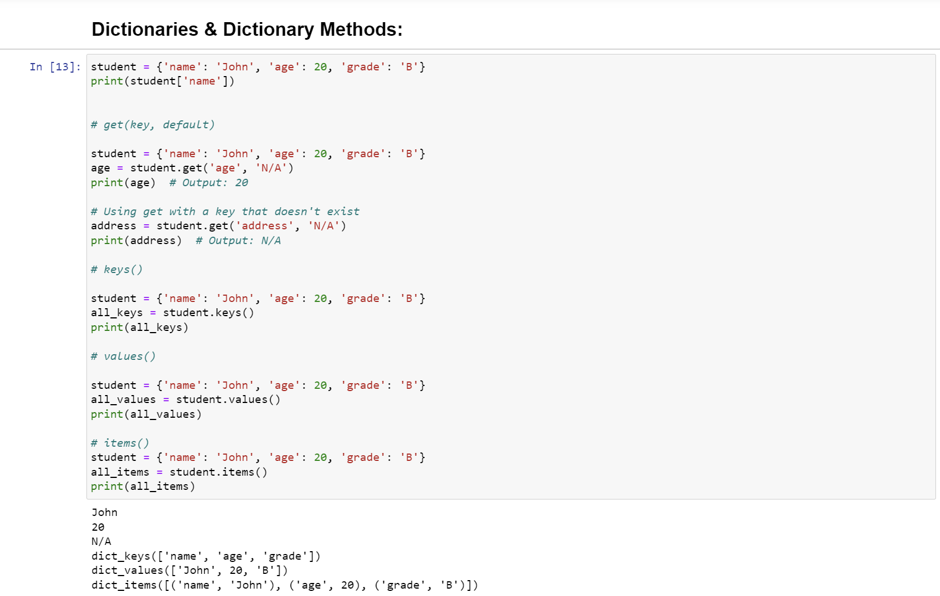

Introduction to Set & Set Methods

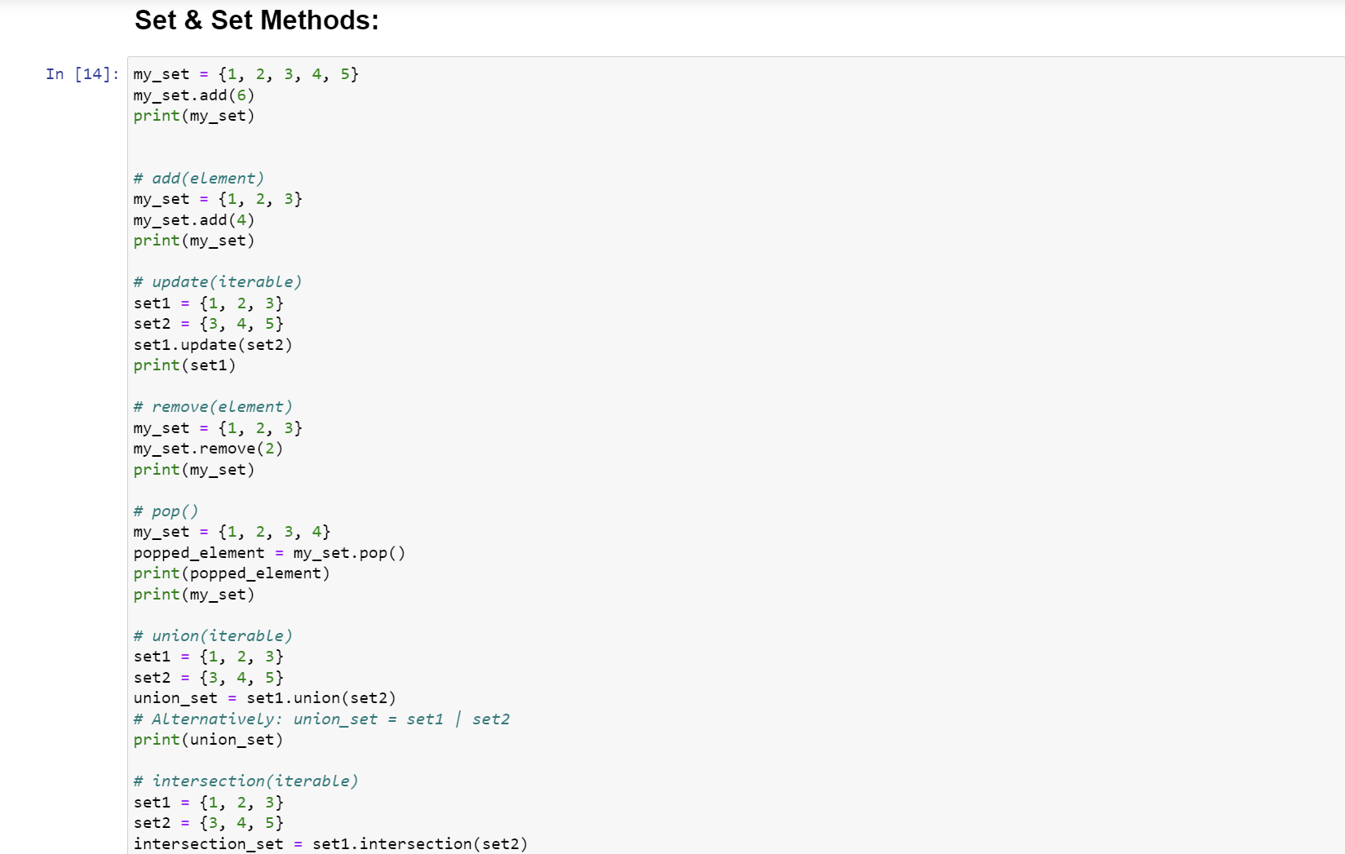

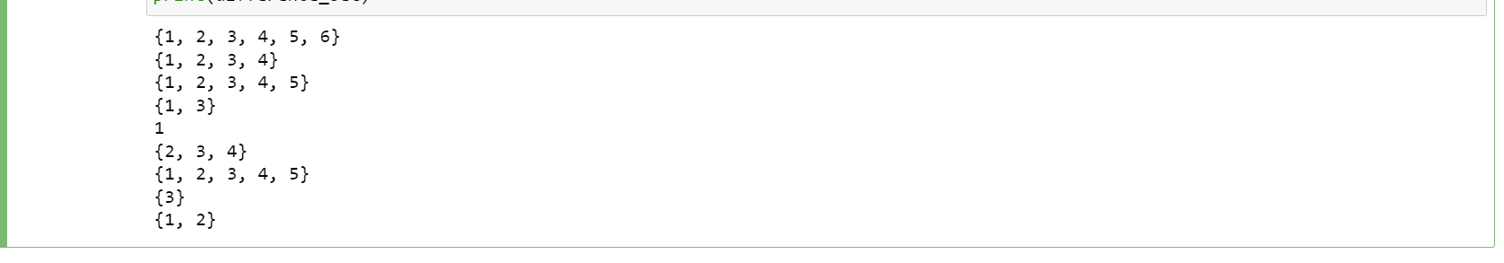

Introduction to Map & Map Methods

